Erosion Control Plan
Due Date: Wednesday, December 6 at 16:00
Overview:
Using the Universal Soil Loss Equation and the attached data, prepare an erosion control plan for the property mapped. The property is to be completely cleared of vegetation, and graded to the configuration shown by the contours. The following computations are required:
- Determine the annual soil loss per acre for both Area X and Area Y if no soil erosion controls are used.
- Determine the total loss of soil (tons/yr) for both Area X and Area Y if no controls are used.
- Compute the proper Cropping Factor needed to lower the average annual soil loss to 5 tons per acre per year for each area.
- Determine the total loss of soil (tons/yr) for each area if controls are used.
- Determine the amount and total cost of straw, wood chips, and crushed stone required to provide the Cropping Factor needed, with attention to keeping costs as low as possible for the client.
Format of the Report:
- Purpose of the Project
- A brief description of the Soil Series (we saw these on our Valley Field Trips, and are also available from the NRCS website and the Rockingham Soils Survey).
- Computations of Soil Losses (per acre, and for total areas X and Y)
  - Without controls
  - With controls
- Recommendations for controlling erosion
  - What materials and amounts would do the job?
  - Estimate of costs of materials (C factor expenses)
  - What are your recommendations? Why? Consider cost, aesthetics, and environmental factors. Plan for both the short and long term conditions.
- Include the property map and show ALL work.

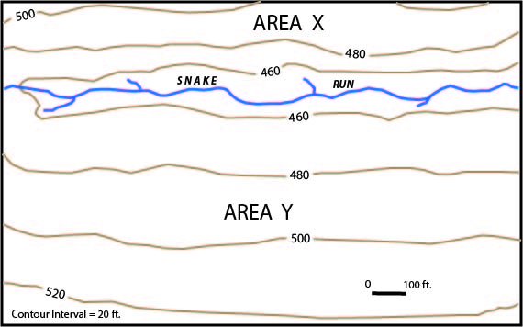
Given:
- Area X and Area Y are divided by Snake Run.
- Area X is underlain by the Weikert Series
- Area Y is underlain by the Encav Series
For K values, see Table 14 –Physical and Chemical Properties of the Soils (column “Erosion factors = K), Soil Survey of Rockingham County, VA http://www.nrcs.usda.gov/Internet/FSE_MANUSCRIPTS/virginia/rockinghamVA1982/rockinghamVA1982.pdf
- Rainfall Factor = central Rockingham County, VA.
- Slope is computed as rise/run * 100.

